Objective

The objective of this test is to ensure that the process of implementing and scheduling SimpleDose Jobs is based on the Batch Run Book

Procedure

- Ensure that jobs are documented in the Batch Run Book
- Jobs are scheduled according to the Batch Run Book

Results/Observations

E.2.1 – Jobs are documented in the Batch Run Book

Internal Audit (IA) obtained a full list of SimpleDose Production jobs from Padmalatha Ajit, Senior Manager, Application Development, on May 24th, 2021 (SimpleDose Production Jobs). IA reviewed the listing to see the names of SimpleDose batch jobs included in the production listing. Contained in the listing provided were a total of 72 production jobs, with a description of what each job does. Padmalatha also provided the SDA Batch Run Book which contained a list of SimpleDose Jobs (SDA Batch Run Book). This listing, similar to the SimpleDose Production Job listing includes the description of what each job does and is further broken down into several categories of job: refresh jobs, migration jobs, Load jobs, ROCM jobs.

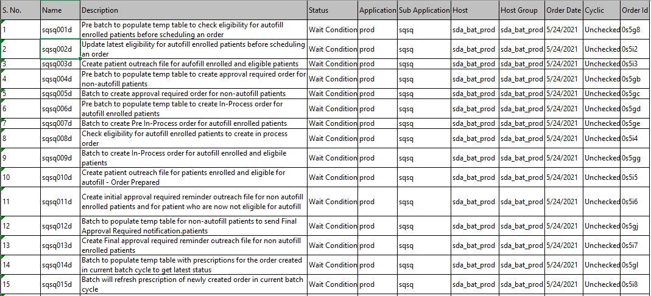

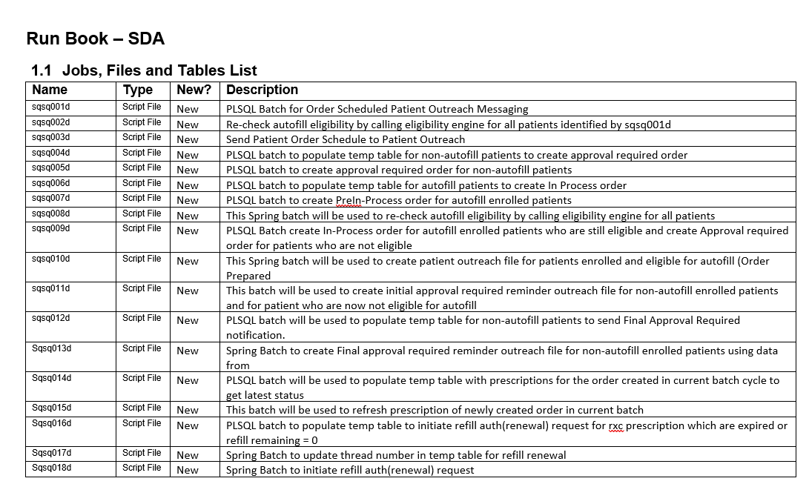
As such, IA concludes that the jobs are documented in the batch run book. No action items or exceptions were noted.

E.2.2 – Jobs are scheduled according to the Batch Run Book

Prior to testing, Internal Audit (IA) requested to see if a small sample of 10% from the Batch Run Book jobs were present in the SimpleDose Job Scheduler. In doing, IA randomly selected 7 Batch run jobs which are: sqsq001d, sqsq014d, sqsq023d, sqsq054d, sqsq087dft, sqsq203dft, and sqsq205dft. Internal Audit (IA) then obtained evidence in the form of print screenshot of batch run book jobs and their respective configuration in the job scheduler from Shekhar Kumar, Application Development Team, on May 28th, 2021 (Job Scheduling Process Job Configuration). In the job scheduler configuration provided, IA observed that all 7 random batch run jobs selected from the sample population were all configured appropriately in the job scheduler. IA also noted that their descriptions tied corrected with the information included in the Production Batch run listing (SimpleDose Production Jobs). Also included in the job configuration is a tab showing when each job will be scheduled to run, run information which has the date the run will be executed, average run time and notification configuration action before job completion. IA also noted that given that the Batch jobs have a status of “Wait Condition”, the respective jobs in the job scheduler had not been assigned an active job run start and end time frame.
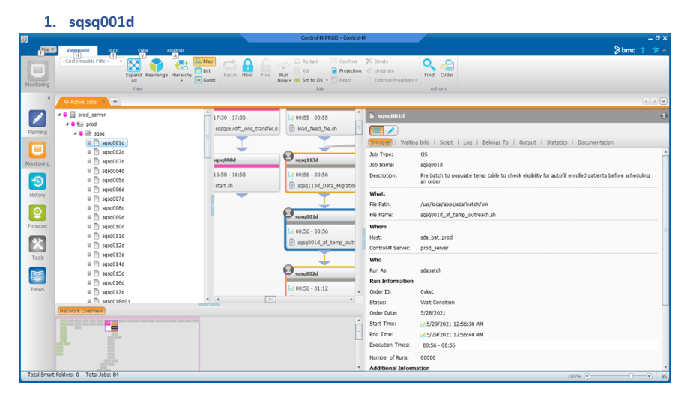
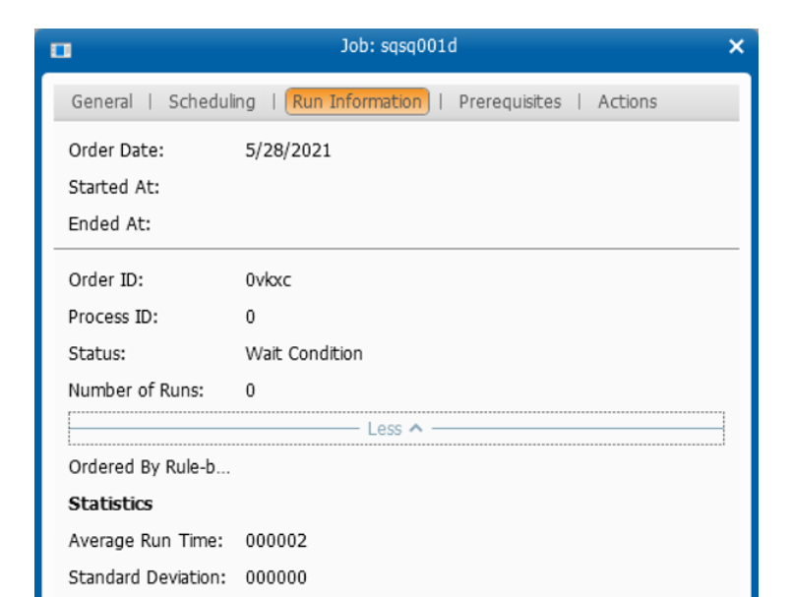
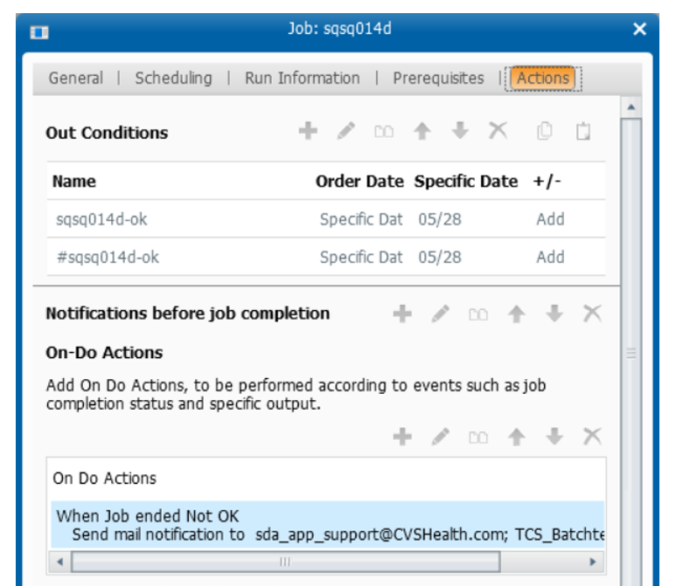

As such, IA concludes that jobs are scheduled according to the Batch Run Book. No action items or exceptions were noted.

Conclusion

This Control appears to be operating effectively.

